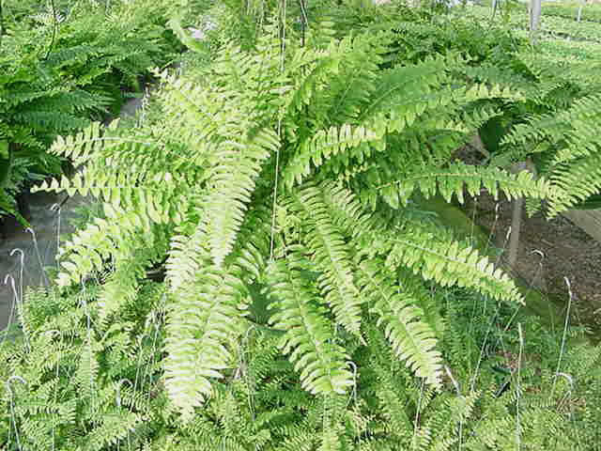

Long green weeping fronds arise from the crown at the soil surface. Fronds are variously cut
Temp: 50 to 70F Degrees
Partial Sun
Keep mixture moist, Mist often

