BROMELIAD

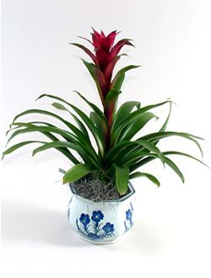

These foliage plants have central floral spikes up to 2 feet tall and 8- to 10-inch long spiny-edged leaves that form a cup that can hold water. In some species, the flower has waxy, colored leaves.
Temp: 62 to 65F night 80 to 85F degrees day
Partial sun to filter light

