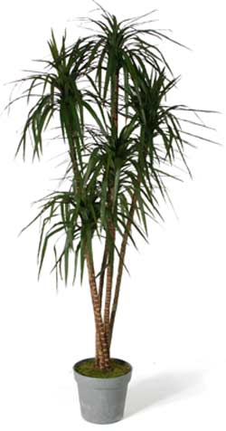

Tree, a pointed-leafed dracaena, with green foliage
Temp: 60 to 80F degrees
Partial sun
Keep moist

