NORFOLK ISLAND PINE

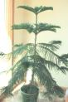

Resembles a true pine tree. Branches are horizontal to main stem, in tiers of bright green, with soft, awl-shaped needles.
Temp: 50 to 65F degrees
Keep Moist
Partial Sun

