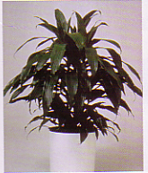

Watering: Moist
Sunshine: weak (partial) sun
Temperature: 60 to 80
Ease of Growth: 2

