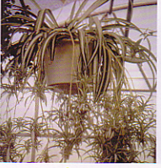

Watering: keep moist
Sunshine: weak (partial) sun
Temperature: 50 to 70
Ease of growth: 1

