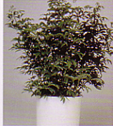
Umbrella Tree
Schefflera digitata
Tall with very small leaves and looks like a small tree

Watering: drench/let dry slightly
Sunshine: weak (partial) sun
Temperature: 40 to 60
Ease of Growth: 1

