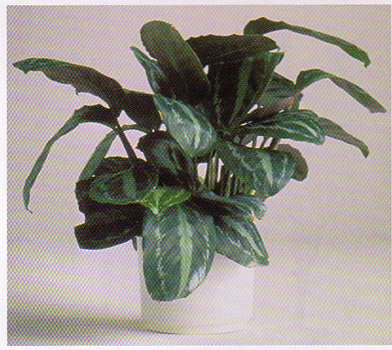

Prayer Plant
Maranta leuconeura
Tall broad hanging leaves

Watering: Keep Moist
Sunshine: weak (partial) sun
Temperature: 60 to 70
Ease of growth: 3

