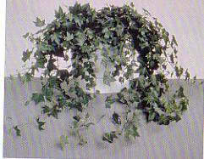

English Ivy
(Hedera helix)

Watering: Drench/let dry slightly
Sunshine: Partial sun
Temperature: 50 to 65 F.
Ease of Growth: 1

Description- This plant is considered a green plant that has no flowers present within its growing period. The leaves are Jagged and three pronged. The English Ivy is mostly used as a hanging plant for decoration.

