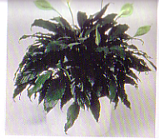

Spathiphyllum
(Spathiphyllum wallisii)

Watering: Quite Moist
Sunshine: Filtered to low light
Temperature: 62 F to 65 F nights, 80 F to 85 F Day
Ease of growth: 1

Description- Considered a green plant but has white leaves on the very top; also known as the peace plant. Big thick leaves are present at the base.

