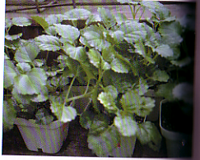

Swedish Ivy
(Plectranthus austalis)

Watering: Keep soil moist
Sunshine: Indirect sun
Temperature: 50 to 65 F
Ease of Growth: 2

Description- Considered a green plant with no flowers. Leaves are in the smaller category with a lot of veins through them, and a half rounded shape. They are used for decoration.

