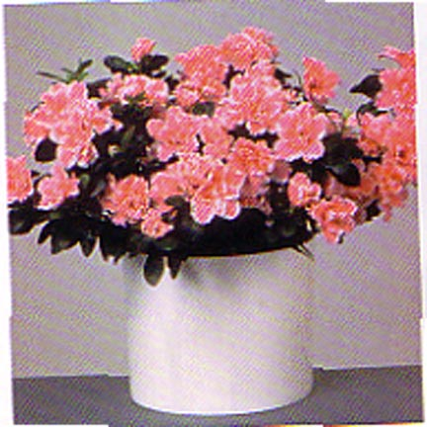



Description:
These perennial shrubs have tough, glossy, smooth-margined evergreen leaves. The large, showy flowers are in terminal clusters and have five white, pink, or red petals. Some horticultural varieties have yellow or orange petals. Common and local names for these plants include "lambkill" and "calfkill". These plants have been used by people to commit suicide. These plants grow wild in the East and cause significant problems there.

