Watering: Moist

Sunlight: Weak (Partial) Sun
Temperature: 60° to 80° Fahrenheit
Ease of growth: 2
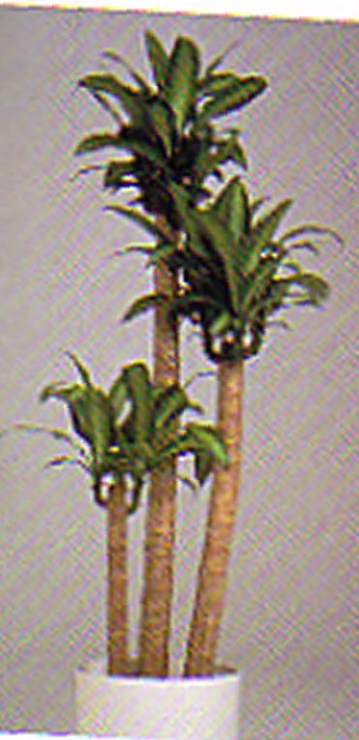

Description:
Flowers. Perennial shrub of the Agave family - Agavaceae. Erect stems, light brown, provided with vertical furrows and horizontal rings. ( In grown-up samples they are devoid of leaves) Very distinctive leaves, lanceolate and hanging, from 8 cm to 1 m long, bright green, , with a yellowish band in the middle. Yellow flowers, very scented in ending panicles, only appearing in adult samples being more than 1,80 m tall. Blooming is usually very rare, since it only happens once or twice throughout its live. It comes from tropical America.

