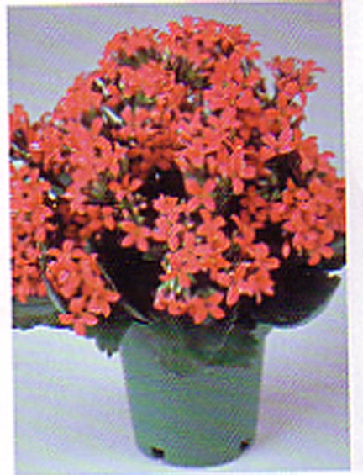

Kalanchoe
Kalanchoe Pinnat a

Description:
Kalanchoe is one of the prettiest and infamous representatives of the succulent’s family. The plant was originally brought from Madagascar to Paris in 1927. Kalanchoe's leaves are fleshy, wide, oval-shaped, with indented edges, appear in turn throughout the stems, are very tender and break easily. Provide plenty of water when the soil seems dry to the touch but do not over water because the roots will rot.

Watering: Drench/let dry slightly
Sunlight: Direct sun to partial sun
Temperature: 55 to 65 degrees Fahrenheit
Ease of Growth: 2

