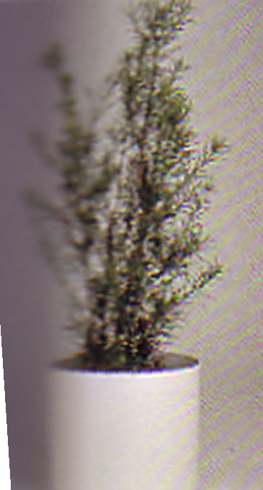
Southern Yew
Podocarpus Macrophyllus
Description:
Height: Slow grower to 15 to 20 ft. tall, 6 to 8 ft. wide, larger with age.

With its dense, upright form, this Podocarpus can become a columnar corner plant. Line them up, with spaces in between, as a repeating element behind traditional perennial borders. The plant has a solid hedge for a manicured privacy screen along property lines and side yards. In warm-winter climates, it makes a great evergreen background that can be shaped to your needs. Excellent choice for front yards needing separation between multistory buildings.

